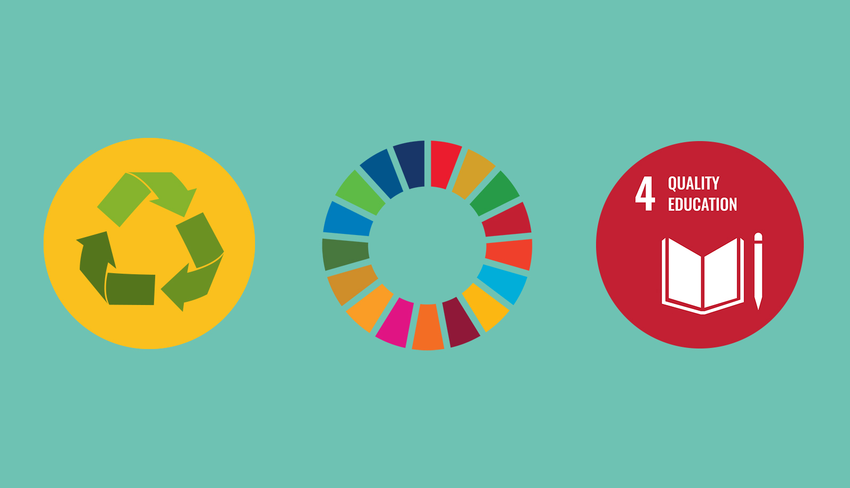

ERASMUS BRUSSELS UNIVERSITY OF APPLIED SCIENCES & ARTS (EhB)

INTERNATIONAL DAYS

4-6 December 2019

The Most Sustainable Resource

Higher Education as Catalyst of Sustainability

**Wednesday December 4th, 2019**

Venue: *Cine Palace, Boulevard Anspach 85, 1000 Brussels (opposite Metro station Bourse/Beurs)*

**10 - 11 am**: Registration

**11 - 12.30 pm**: Opening session hosted by Aubry Cornelis, head of EhB MARCOM

* Welcome by Mrs. Ann BRUSSEEL, President of EhB
* Keynote Speaker Dr. Jan TERLOUW, former president of Democrats 66, Deputy Prime Minister in the Van Agt II Government, author of several children books and enthusiast advocator for sustainable development in The Netherlands
* Bas LITJENS, Board Member of the Dutch National Students’ Association
* ‘*Al Camino Frente a Mi’* a documentary directed by Aisha ADEPOJU, RITCS Alumna. Kevin Deruyver (performing as coach in the documentary) will join us on stage.

**12.30 – 1.30 pm**: Reception

**1.30 – 2pm**: Lunch offered to workshop participants

**2 - 4 pm**: Workshops open to all registered guests, EhB-staff and students (CinePalace)

* **Implementing sustainability in your curriculum.** Leen Audenaert and Peter Schildermans, Flemish Government -  Sustainable Higher Education’

*This workshop is addressed to all teaching staff interested in curriculum development. You will be guided through a process which allows you to take the first steps in building a new curriculum. Some energizing examples will be shown on what sustainability and sustainable development goals mean in higher education. An open and informal space will be created to share your ideas.*

* **Working on sustainability and the circular economy with the OVAM SIS Toolkit**. Miranda Geusens and Liesbet Van Ackeleyen (OVAM)

*Do you want to know more about tools for the circular economy and sustainability? Take part in the hands-on workshop 'OVAM SIS Toolkit' and work together on a concrete case. The OVAM SIS Toolkit '(Sustainable Innovation System) is an instrument that provides guidance towards integrating sustainability principles in innovation and design processes to create sustainable value. Participants will be offered an OVAM SIS Toolkit.*

<http://ecodesign.vlaanderen-circulair.be/en/tools/ovam-sis-toolkit>

* **Education for sustainability in a multi-faceted tomorrow – A Futures Literacy Lab**

Maya Van Leemput, Kim De Vidts, Eva De Smedt, Yannick Dujardin (EhB Researchers Open Time | Applied Futures Research) (2-5 pm)

*This Lab is open to all interested guests, EhB staff and students. To engage with the exceptional challenge that sustainability is, you are invited to broaden your perspective of the here and now to the long-term future and the greater whole. Take part in this colorful and relaxed activity to strengthen your futures literacy in order to shape together tomorrow’s ideas on sustainability in higher education.*

**7.30 pm: Welcome Dinner** for registered participants, Taverna du Passage, Galeries de la Reine 30, 1000 Brussels (Metro Central Station or Bourse)

**Thursday December 5th, 2019**

Morning and afternoon:   
  
Welcome at the various EhB-Departments/Schools of Art followed by guest lectures (for details see EhB website: <https://www.erasmushogeschool.be/en/events/international-days-2019>

Evening Program for registered participants

* **From 5 pm onwards to 10 pm**: Enjoy the **Brussels Museums Nocturne** which gives you access to 4 museums[1] located in the center of Brussels. Do not miss the closing party in the Saint-Géry Hall!

Venue: different locations in center of Brussels (see brochure enclosed)

<https://brusselsmuseumsnocturnes.be/en/calendar/>

* **7.30 pm: Film Performance** at Royal Institute for Theatre, Cinema & Sound (RITCS): Young Female Directors: Compilation of graduation films

Venue: Rue Antoine Dansaert 70, Brussels (Metro Bourse or St Catherine)

* **8 pm** : Attendance of the **Musical “Nine**” performed by our Musical Students

Venue: EhB, Nijverheidskaai 170, 1070 Brussels (Metro Delacroix)

**Friday December 6th 2019**

**9.30 am - 2.30 pm**: Visit the innovative sustainable **Cultureghem Urban Space Project** at the premises of the Anderlecht Slaughterhouse

Venue: Ropsy Chaudron 24, 1070 Brussels (Metro Clemenceau, exit Rue Ropsy Chaudron, just cross the street and enter the gate in front of you where the food market is taking place, enter the first building at your left side) <https://www.cultureghem.be/en/contact>

* 1. **- 10 am**: Introduction to the **Cultureghem Urban Space Project**

1. **- 12 am**: Participation in one of the following 3 educational workshops:

* *KOOKMET: be part of the city’s best pop-up restaurant by shopping and preparing a healthy and affordable meal cooked on funky mobile kitchens which you will share afterwards with your colleagues*
  + - [*https://www.cultureghem.be/en/wat-kookmet*](https://www.cultureghem.be/en/wat-kookmet)
* *BIGH’s URBAN FARM: learn about the fish farm, the greenhouse and the rooftop garden built on the FoodMet and get an insight into the applied aquaponic method through a ludic workshop.*
* *LE CHAMPIGNON DE BRUXELLES: visit the cellars of the slaughterhouse which are a perfect environment for mushroom production. Tons of beer waste are transformed into delicious shiitake!*

**12 am – 1.30 pm**: Lunch

**1.30 – 2.30 pm**: Final presentation on the future of the **Cultureghem Urban Space Project**

**3-4 pm**: **Mobility – Can we collaborate besides the traditional Erasmus mobility?**

Venue: EhB, Nijverheidskaai 170, Brussels (located next to the Cultureghem Project site), Room B101

*EhB encourages short mobility (3-5 days) activities and wants to reinforce its virtual mobility activities in the future. During this session, you will be invited to exchange good practices and discuss possible future cooperation.*

**8 pm** : Attendance of the **Musical “Nine**” performed by EhB Musical Students

Venue: EhB, Nijverheidskaai 170, 1070 Brussels (Metro Delacroix)

1. Access to the following museums are free of charge: National Bank, Marc Sleen and Halles St- Géry. An additional ticket which you will find in your file gives you access to one additional museum (see program enclosed).